Assignment 5 :

1.List all the main components you find inside a desktop PC after opening the cabinet, and write a short description (1-2 lines) for each.
-- Motherboard – The main circuit board of the computer. It connects all the hardware components and allows them to communicate.

CPU (Processor) – The brain of the computer. It processes instructions and performs calculations.

CPU Cooler (Fan and Heatsink) – Keeps the CPU cool by removing heat and preventing overheating.

RAM (Random Access Memory) – Temporary memory that stores data and programs currently being used by the CPU.

Storage Drive (SSD or HDD) – Stores the operating system, applications, and personal files permanently.

GPU (Graphics Card) – Processes graphics, videos, and games. It can be integrated or a dedicated graphics card.

Power Supply Unit (PSU) – Converts AC power from the wall into DC power required by the computer components.

Cabinet (Case) – The outer enclosure that holds and protects all the internal components.

Case Fans – Improve airflow inside the cabinet to keep the computer cool.

Optical Drive (Optional) – Reads and writes CDs and DVDs if installed.

SATA Data Cable – Connects storage drives (HDD/SSD) to the motherboard for data transfer.

Power Cables – Supply electrical power from the PSU to the motherboard, storage drives, and other components.

CMOS Battery – Keeps the BIOS settings and system clock saved even when the computer is turned off.
2.Take clear photos or draw labeled diagrams of each step as you disassemble a desktop PC, and organize them in a document with captions explaining what you did at each step.<br><br><em><strong>Hint:</strong> Include steps like unplugging power, removing side panel, disconnecting cables, and removing RAM, HDD/SSD, and motherboard.</em>
-----
SMPS—switch mode power supply
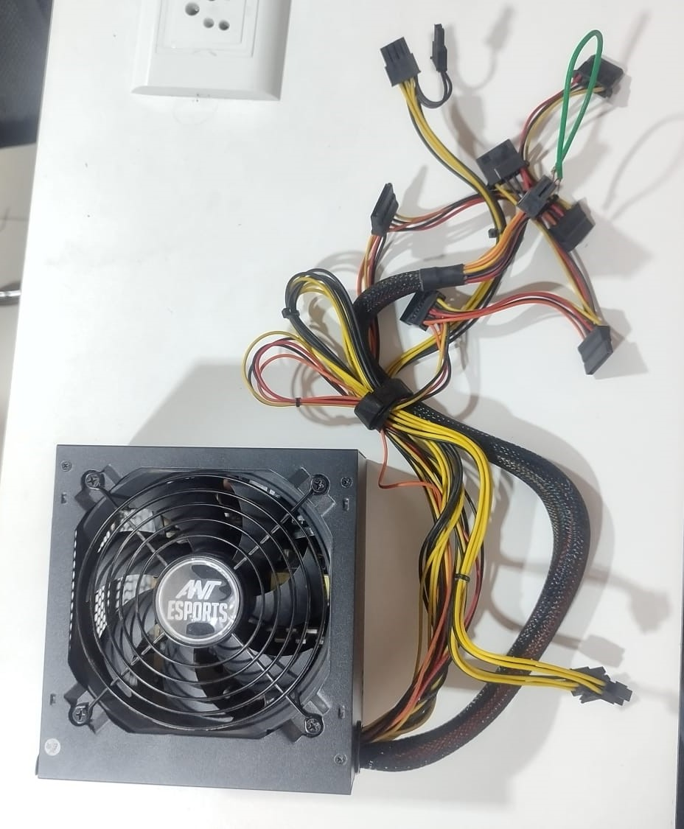
SSD—solid disk drive
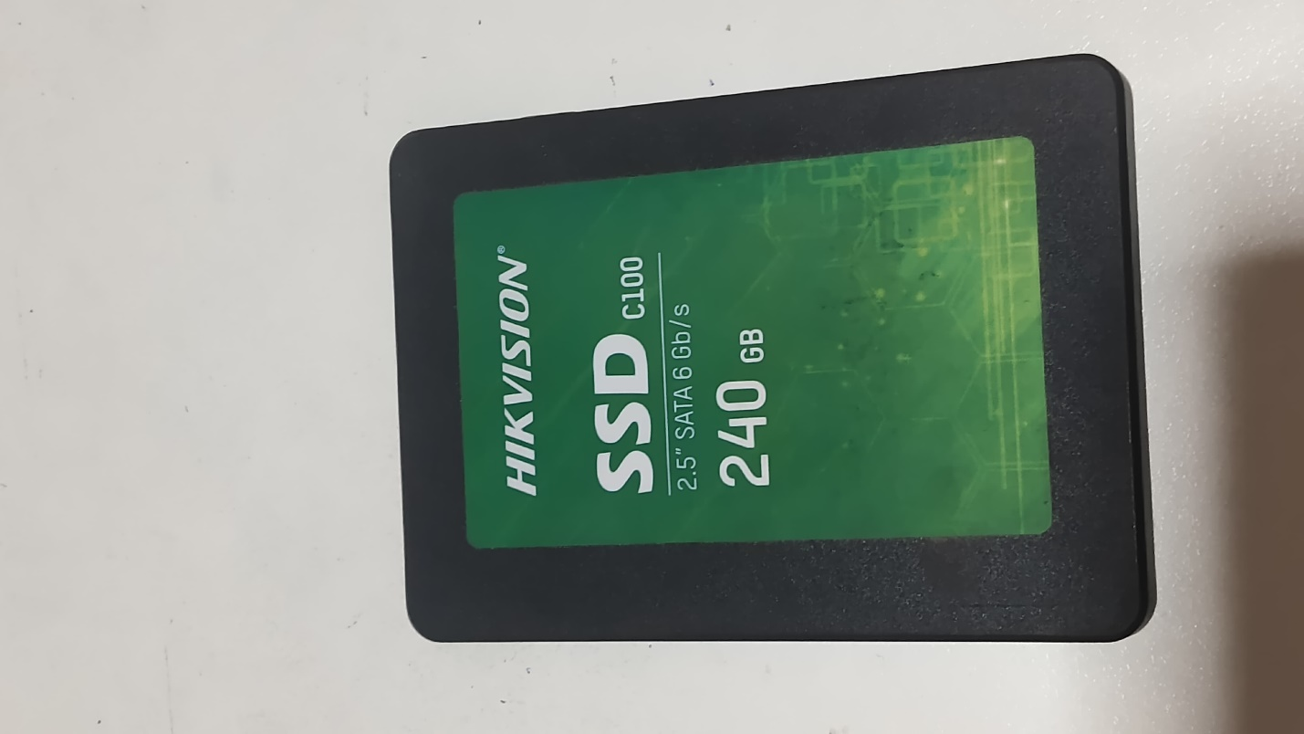

CPU—central processing unit
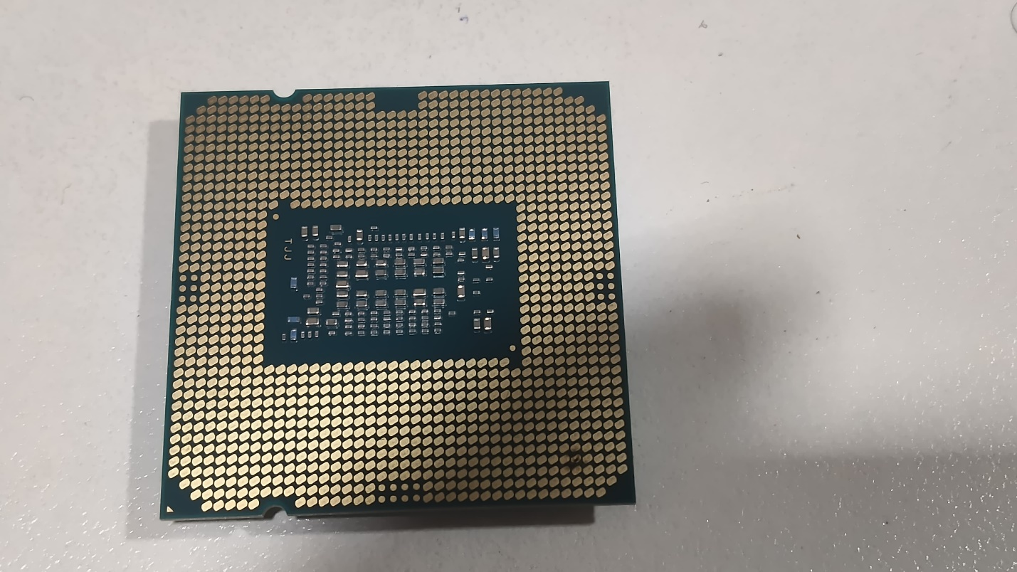

GPU-graphics processing unit
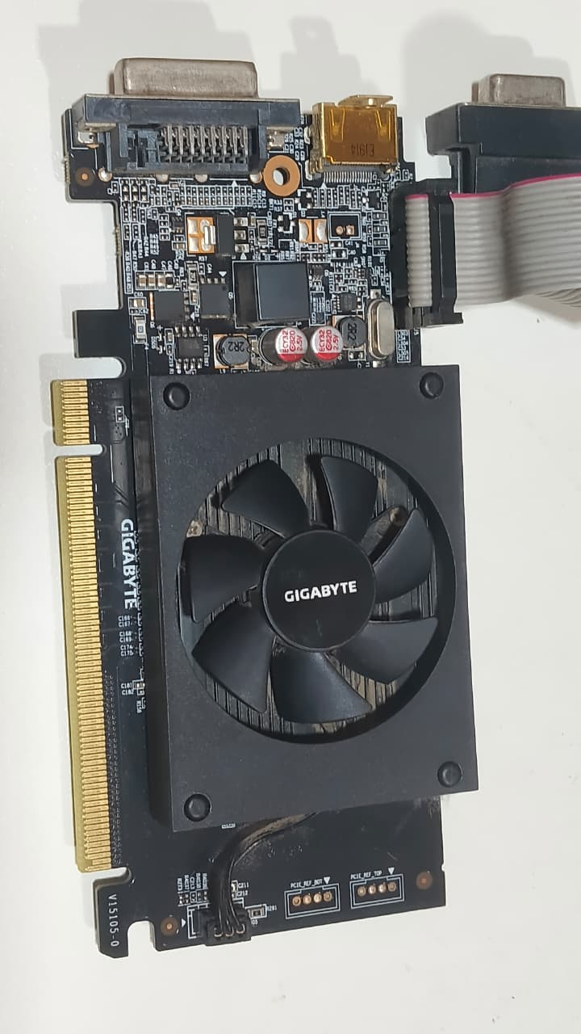

RAM-random access memory
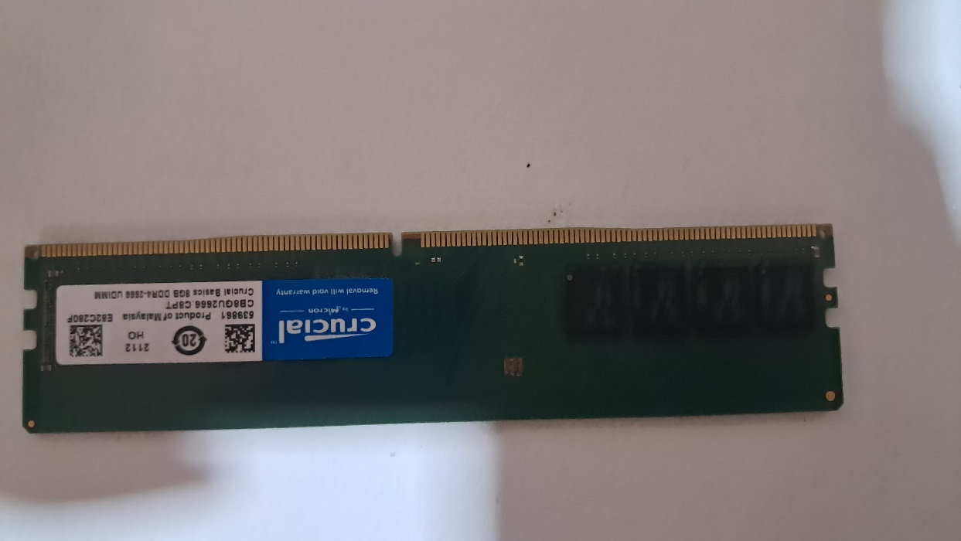
HDD-hard disk drive
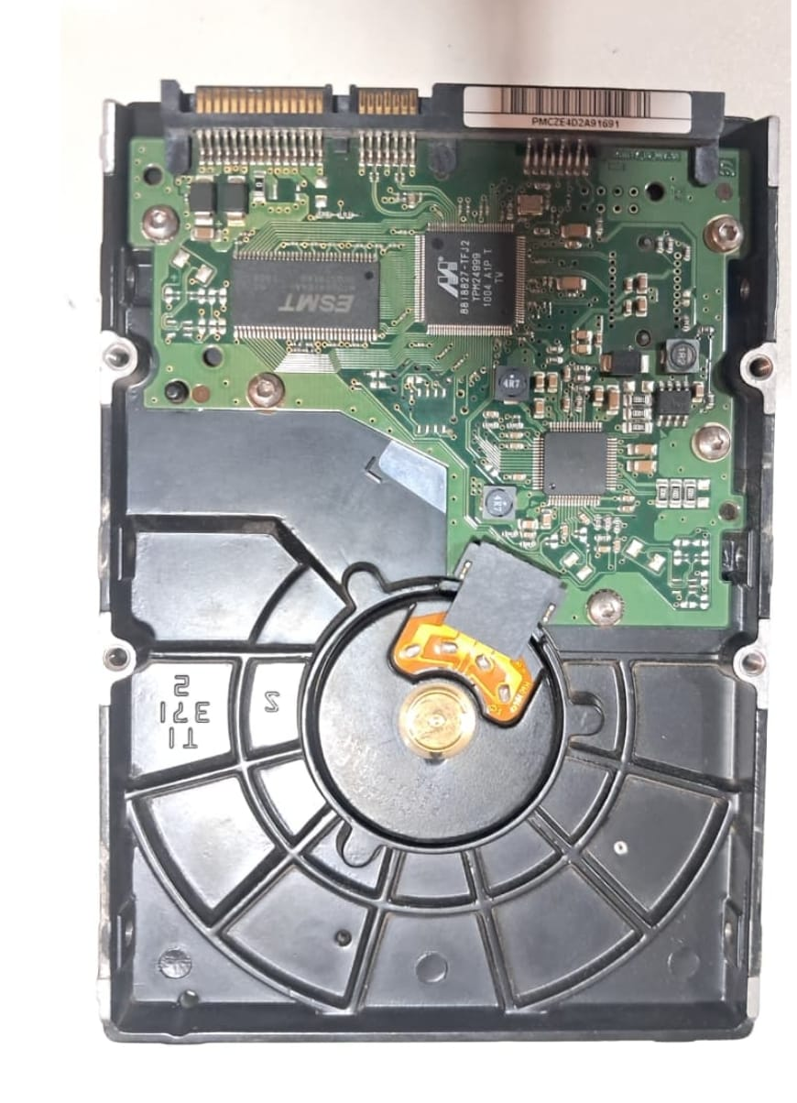
Motherboard
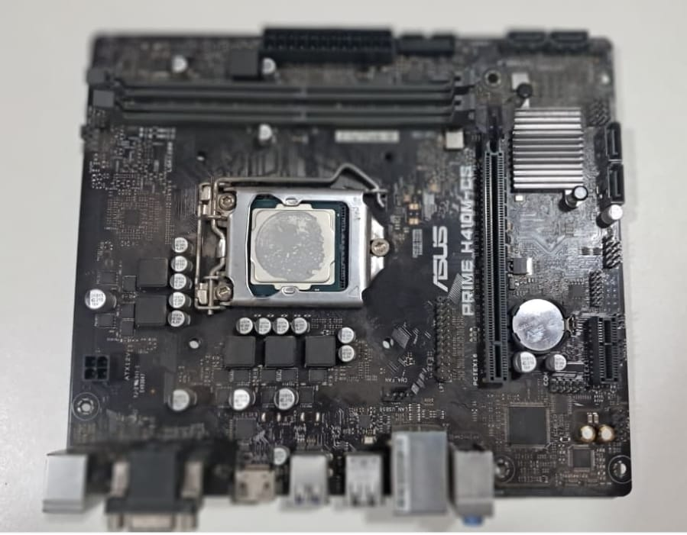

Desktop PC Disassembly Steps
- Shut down the computer.
- Unplug the power cable and all external cables.
- Press the power button for 5–10 seconds to discharge remaining power.
- Remove the side panel of the cabinet.
- Identify all internal components.
- Disconnect the motherboard power cables (24-pin and CPU power cable).
- Disconnect SATA data and power cables from the HDD/SSD.
- Remove the graphics card (if installed).
- Remove the RAM modules.
- Remove the HDD/SSD from the drive bay.
- Disconnect the CPU fan cable.
- Remove the CPU cooler (heatsink and fan).
- Remove the CPU (optional, if required).
- Unscrew and remove the motherboard.
- Remove the power supply unit (PSU) if required.
- Arrange all components safely and label them.

3.Reassemble the PC you disassembled, documenting each step with a brief explanation of what you connected or installed and why the order matters.
--PC Reassembly Steps
- Install the motherboard – Place the motherboard inside the cabinet and secure it with screws. This provides the main base for connecting all other components.
- Install the CPU – Carefully place the processor into the CPU socket and lock it in place. The CPU must be installed before the cooler.
- Apply thermal paste and install the CPU cooler – Apply a small amount of thermal paste and attach the heatsink/fan. This helps transfer heat away from the CPU.
- Install the RAM – Insert the RAM sticks into the correct motherboard slots until they click into place. RAM is easier to install before large components block access.
- Install the HDD/SSD – Secure the storage drive in its mounting area and connect the SATA/data and power cables.
- Install the power supply (PSU) – Secure the PSU inside the cabinet. It provides power to the motherboard, drives, GPU, and other components.
- Install the graphics card (GPU) – Insert the GPU into the PCIe slot and secure it with a screw. Connect its power cable if required.
- Connect the motherboard power cables – Connect the 24-pin ATX motherboard cable and the 4/8-pin CPU power cable. These provide power to the motherboard and processor.
- Connect storage and other cables – Connect SATA cables, front-panel connectors, USB, audio, and other required cables. Correct connections are necessary for the components and case buttons to work.
- Connect case fans – Connect the fan cables to the appropriate motherboard fan headers or PSU connectors to provide proper cooling.
- Check all connections – Make sure RAM, GPU, power cables, storage cables, and other components are firmly connected. This prevents boot failures and loose connections.
- Close the cabinet – Reinstall the side panel and tighten the screws after confirming everything is correctly installed.
- Connect external devices – Connect the monitor, keyboard, mouse, network cable, and power cable.
- Turn on and test the PC – Switch on the PSU and start the computer. Check that the display appears and that the CPU, RAM, storage, fans, and other components are detected.
Why the order matters: Components such as the motherboard, CPU, cooler, and RAM are easier to install before the cabinet becomes crowded. Power and data cables are connected after the main components are installed, followed by a complete check before powering on the PC.

4. Create a checklist of safety precautions and tools needed before starting the PC assembly/disassembly process, and explain why each is important.
PC Assembly/Disassembly Safety Checklist---
Safety Precautions--
Turn off the PC completely — Prevents electrical shock and damage to components.
Unplug the power cable — Ensures no electricity is flowing through the PC.
Remove all connected cables and devices — Makes the PC safer and easier to work on.
Work on a clean, dry, flat surface — Prevents components from falling or getting damaged.
Use an anti-static wrist strap — Protects sensitive parts such as RAM, CPU, and motherboard from static electricity.
Touch a metal part of the cabinet before handling components — Helps discharge static electricity from your body.
Hold components by their edges — Avoids touching sensitive circuits and connector pins.
Keep screws in a small container — Prevents losing screws and mixing different screw types.
Do not force any component — Components should fit correctly; forcing them can damage the motherboard or connectors.
Keep liquids away from the PC — Prevents short circuits and electrical damage.
Take photos before disconnecting cables — Helps you reconnect everything correctly during reassembly.

Tools Needed--
Phillips-head screwdriver — Used to remove and install most PC screws.
Flat-head screwdriver — Useful for certain screws or clips when required.
Anti-static wrist strap — Protects components from electrostatic discharge (ESD).
Small container or magnetic tray — Keeps screws and small parts organized.
Compressed air/dust blower — Removes dust from fans, heatsinks, and other components.
Soft brush — Helps remove dust from delicate areas without scratching them.
Thermal paste — Needed when reinstalling a CPU cooler to improve heat transfer from the CPU to the heatsink.
Cable ties/Velcro straps — Helps organize cables during assembly.
Good lighting — Makes small connectors, screws, and motherboard labels easier to see.

